Trainer Aircraft
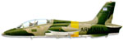 | M.B.339A
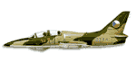 | L-39 Albatros
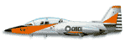 | AT-3 Tzu-chung
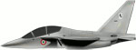 | M-346 Master
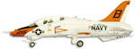 | T-45A Goshawk
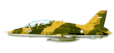 | Hawk
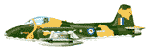 | Strikemaster
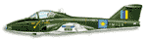 | CL-41 Tutor
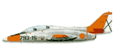 | C-101 Aviojet
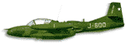 | A-37 Dragonfly
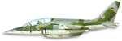 | Alpha Jet
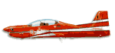 | EMB-312 Tucano
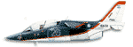 | IA 63 Pampa
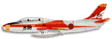 | T-1
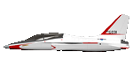 | T-50 Golden Eagle
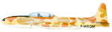 | T-33 T-Bird/Shooting Star
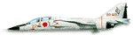 | T-2
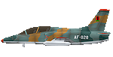 | K-8 Karakorum
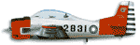 | T-28 Trojan
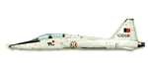 | T-38 Talon
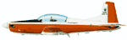 | PC-7 Turbo Trainer
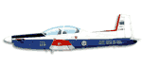 | PC-9
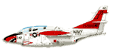 | T-2C Buckeye
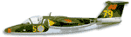 | 105
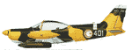 | SF.260
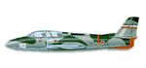 | G-2 Galeb
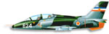 | G-4 Super Galeb

